

**School of Information Technology**

Course : Diploma in Business Informatics

Subject : ITP282 - Enterprise Application Development & Project

AY / Sem : 2018 S2

Practical 1b: Understand the difference between Code Behind and Non-Code Behind ASP.NET web pages.

OBJECTIVES:

By the end of this Practical students should understand:

1. The differences between Code Behind and Non-Code Behind ASP.NET web pages.
2. The differences in the Page Directives of both types of web pages.
3. How the Page Directives link the .aspx file to its respective Code Behind .cs file.

# Exercise 1 (Codes in separate file)

1. Create a new Visual C# web site with project name **ITP282_Lab1b**.
2. Find *Default.aspx* in the *Solution Explorer* and click on the ⏵icon next to it. Notice that *Solution Explorer* now reveals another file below *Default.aspx*. What is the name of the file?

Answer:

1. Recall from the lecture slides: where is the Page Directive of *Default.aspx*?

Answer:

1. Examine *Default.aspx's* Page Directive and find the *CodeFile* attribute.
   1. What is the value of the *CodeFile* attribute?
   2. What do you notice about this and the answer to step 2.

Answer:

1. In Solution Explorer, double-click *Default.aspx.cs* to open it.
2. Look for the line that’s starts with *public partial class*. What is the name of the partial class (the name is the word after the word class)?

Answer:

1. Look for the **inherits** attribute of the Page Directive of *Default.aspx*.
   1. What is its value?
   2. What do you notice about this and the answer to step 6?

Answer:

1. Create a new web form named *NotCodeBehind.aspx* by (see Figure 1):
   1. Select *Web Site 🡺 Add New Item…*.
   2. Select *Visual C#* and *Web Form*.
   3. Name the file *NotCodeBehind.aspx*.
   4. Un-tick *Place code in a separate file* checkbox.
   5. Tick *Select master page* checkbox. (Master Pages will be covered in a later lesson.)
   6. Click the *Add* button.
2. In the *Select a Master Page* dialog (see Figure 2):
   1. Select S*ite.master*.
   2. Click the *OK* button.

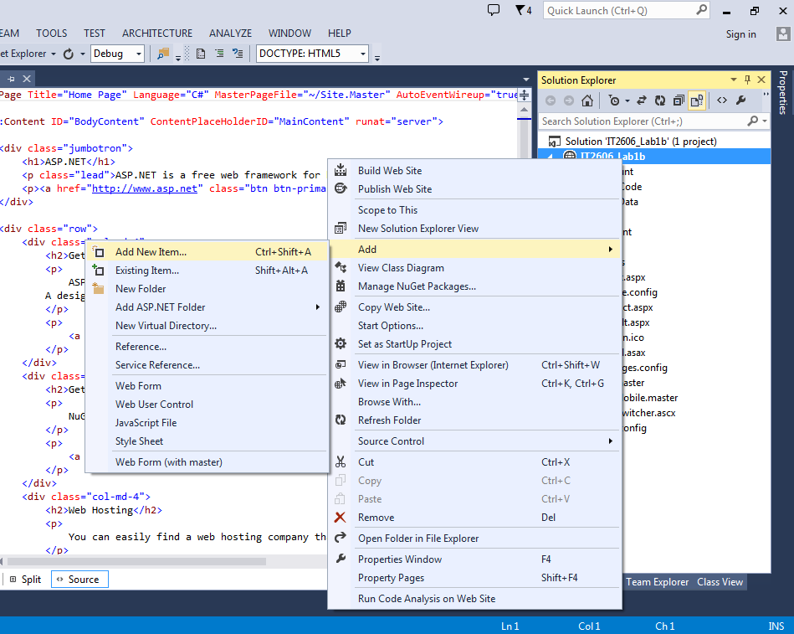

Figure 1a

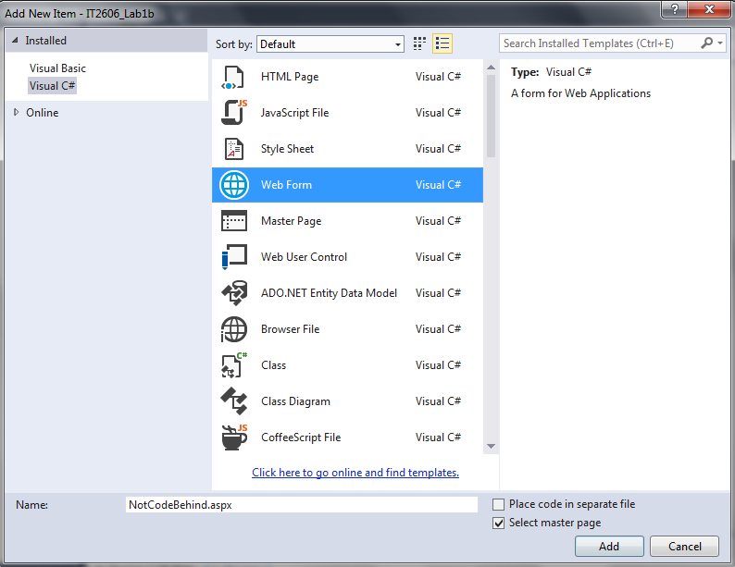

Figure 1b

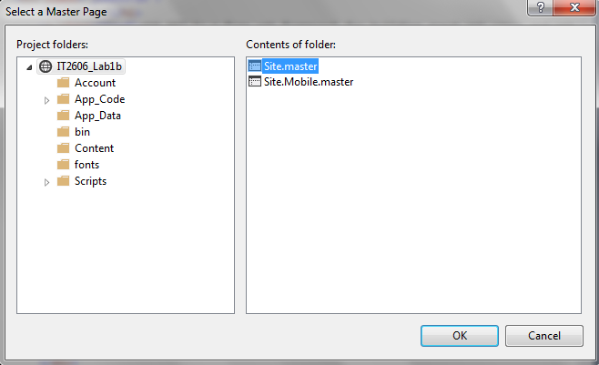

Figure 2

1. Find *NotCodeBehind.aspx* in *Solution Explorer*. Is there an⏵icon next to it?

Answer:

1. Right-click the tab for *NotCodeBehind.aspx* and select *New Horizontal Tab Group* (see Figure 3). VS will now display *NotCodeBehind.aspx* below *Default.aspx*.

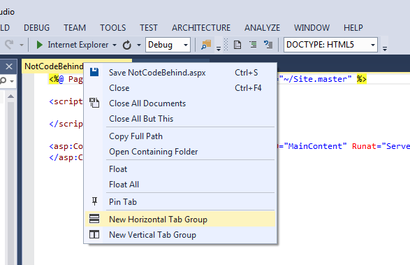

Figure 3

1. Compare the Page Directives of both files. What attributes are missing from the Page Directive in *NotCodeBehind.aspx*?

Answer:

1. What extra tags can be found below the Page Directive in *NotCodeBehind.aspx*?

Answer:

1. Right-click the tab for *NotCodeBehind.aspx* and select *Move to Previous Tab Group*. (You can also just drag the *NotCodeBehind.aspx* tab and drop it next to the *Default.aspx* tab.)
2. Switch to *Default.aspx*. (Click on the *Default.aspx* tab.)
3. Delete everything between <asp:Content ID="BodyContent"… and </asp:Content>. You should end up with Figure 4.

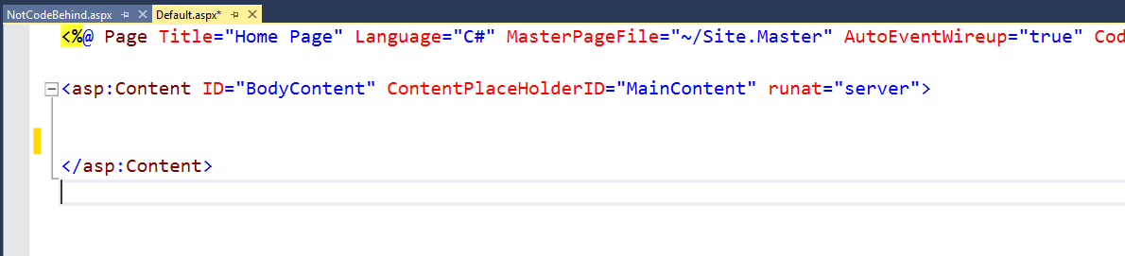

Figure 4

1. Add a *Label* control from the *Toolbox* into both *Default.aspx* by:
   1. Switch to *Design* view of *Default.aspx*.
   2. Click the *Toolbox* tab to open the *Toolbox* panel. It may take a few minutes for the *Toolbox* panel to open and load its contents.
   3. Click the *Pin* icon at the top right corner of the *Toolbox* panel to keep it open permanently (see Figure 5). You can click it again to make it auto hide when not in use.

Find *Label* in the *Toolbox* panel and drag it to the purple outlined box in *Default.aspx* (see Figure 6).

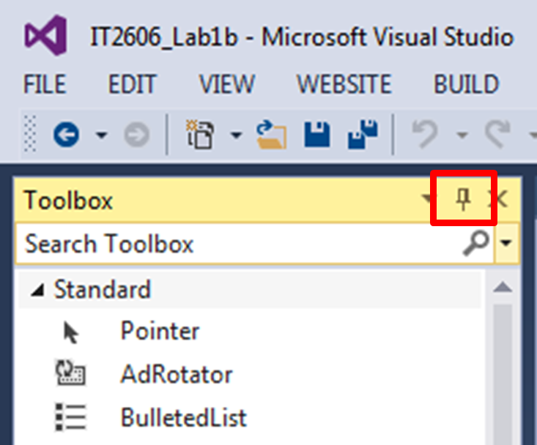

Figure 5

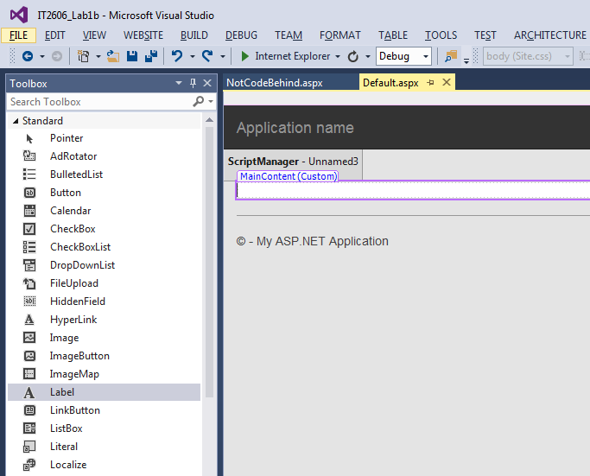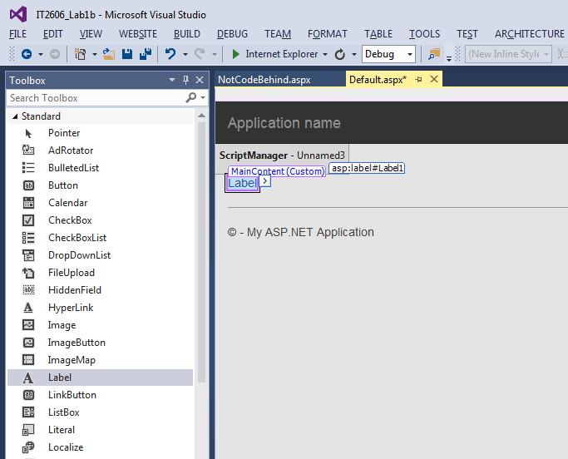

Figure 6

1. Switch to *Source* view. What has VS inserted into the ASP.NET code?

Answer:

1. What is the value of the *ID* attribute in the newly inserted code?

Answer:

1. Switch to or open *Default.aspx.cs*.
2. Add the code in Figure 7 into the Page_Load method.

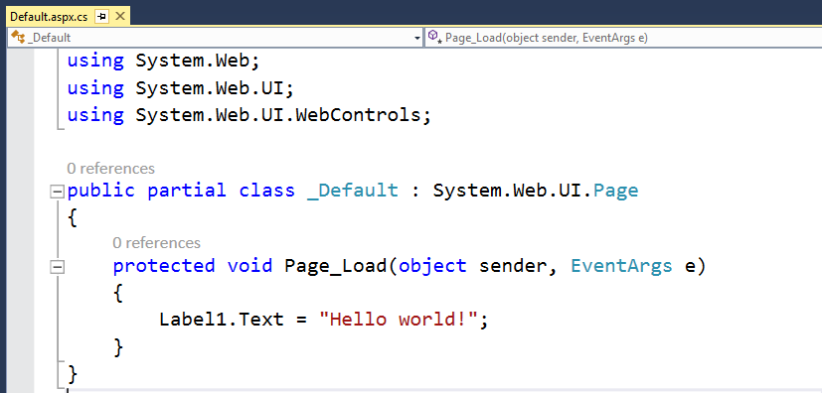

Figure 7

1. Notice that we can reference the *Label* in *Default.aspx* using its *ID*.
2. Test *Default.aspx* using the methods you learnt in the previous lesson. When the page opens in the web browser you should see that where *Label1* was, is the text "Hello world!"
3. Close the web browser.
4. Add a *Label* control to *NotCodeBehind.aspx* using the same method as above.
5. Double-click anywhere in the empty grey parts of *NotCodeBehind.aspx* web page in *Design* view. *VS* will switch to *Source* view and automatically add the following between the <script></script> tags.

protected void Page_Load(object sender, EventArgs e)

{

}

1. Where does *Default.aspx* add C# code?

Answer:

1. Where does *NotCodeBehind.aspx* add C# code?

Answer:

1. Add the code in Figure 8 into the Page_Load method of *NotCodeBehind.aspx*.

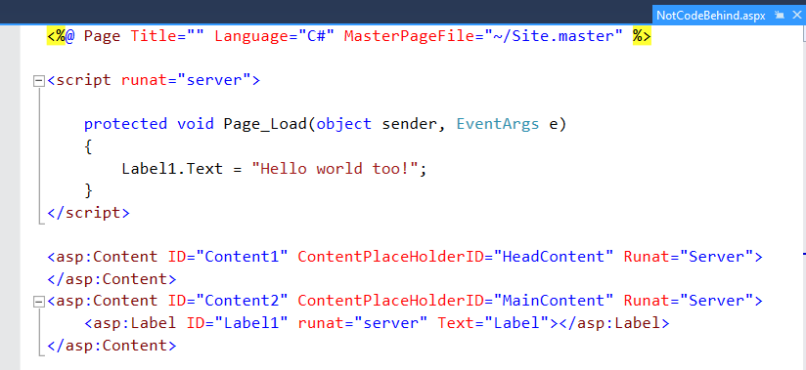

Figure 8

1. Test *NotCodeBehind.aspx*.

Both pages will display their respective messages but the placement of the C# codes is different. If we tick the *Place code in a separate file* checkbox, *VS* will create an *.aspx* web page with a Code Behind file, like *Default.aspx*. By default, *VS* will create the code behind file with same name as the *.aspx* page, but with an additional .cs extension.

If we do NOT tick the *Place code in a separate file* checkbox, VS will create a standalone *.aspx* web page without a code behind file.

ASP code is mainly used for building the user interface. Visual C# is a used for programming the logic of the web application. By separating the ASP and C# code into separate files, it allows the web designer and the programmer to work independently.

**For this module, unless otherwise instructed, all Web Forms must be created with Code Behind C# files.**

***========== End ==========***